BLIND SQL INJECTION EXPLOITATION

Project: Internship Onboarding and Environment Setup
Student: Mbainlakong Josephine Keh
1. Introduction
Blind SQL Injection is a security problem in websites. It happens when what a user types is added to a database query without protection. The website does not show database data directly, but we can know if a condition is true or false by checking how the website responds.
I tested this in DVWA in a safe lab.
2. Objective
I wanted to:
Find Blind SQL Injection problem.
Test true and false SQL conditions.
Check how website responds differently.
Understand why it happens and what damage it can cause.
Learn how to fix it.
3. Tools Used
Kali Linux
DVWA
Web Browser
MySQL database
VirtualBox for safe testing
4. Procedure
Step 1 - Configure DVWA
I opened DVWA and set security level to Low.
Step 2 - Open SQL Injection (Blind)
I went to SQL Injection (Blind) page in DVWA and typed normal input like 1 and submitted.
Screenshot - Normal Input
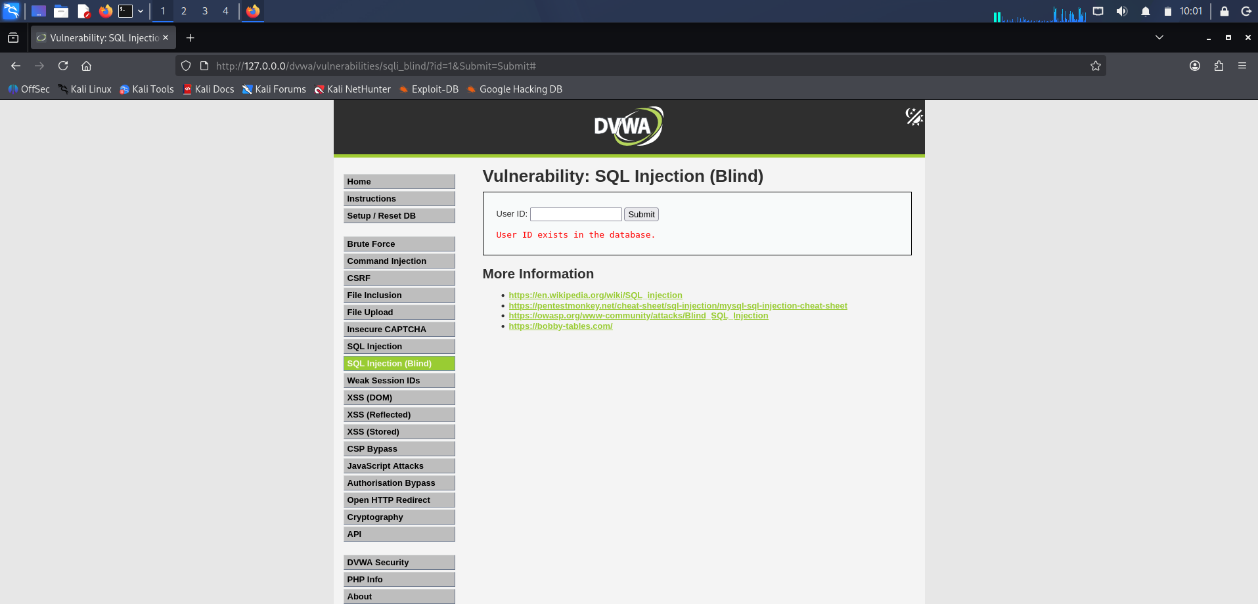
Step 3 - Test SQL Conditions
I tested true and false SQL conditions and compared the responses.
Screenshot - Different Responses
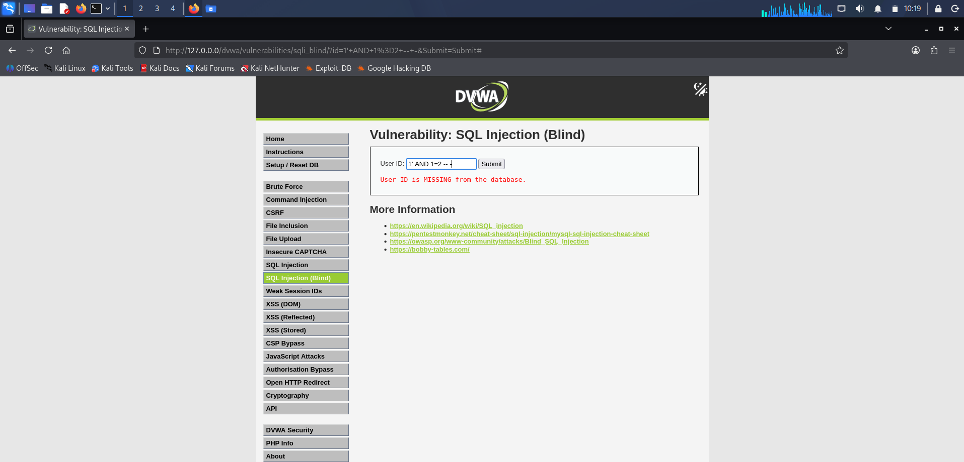
5. Results
The results I observed in DVWA lab were:
Test 1 - Normal Input:
Input: 1
Result: Website showed User ID exists. This is normal response.
Test 2 - True Condition:
Input: 1' AND '1'='1
Result: Website still showed User ID exists. Condition is true, so website behaves like normal.
Test 3 - False Condition:
Input: 1' AND '1'='2
Result: Website showed User ID is missing. Response changed. Condition is false.
Test 4 - Conclusion from Tests:
Because response is different for true and false, it proves the input is going into database query. This confirms Blind SQL Injection vulnerability exists.
Summary
Input Type - Example - Response - Meaning
Normal - 1 - User ID exists - Website working
True Condition - 1' AND '1'='1 - User ID exists - True condition accepted
False Condition - 1' AND '1'='2 - User ID is missing - False condition changes response
This difference in response is what attacker uses to guess database information.
6. Why It Happens
It happens because website takes user input and puts it directly into SQL query without protection.
Flow is:
User types input, website makes SQL query, database runs query, website shows response.
7. What Can Happen In Real Life
In real website, Blind SQL Injection can allow someone to get database information by testing many true and false questions. It can allow unauthorized access.
I only tested in DVWA lab.
Use prepared statements and parameterized queries.
Check user input and allow only safe values.
Do not add user input directly into SQL query.
Give database user only small permission.
Do not show database errors to users.
Test website regularly for SQL injection.
9. Conclusion
I was able to test Blind SQL Injection in DVWA by comparing different responses for true and false conditions. The results show clear difference between true and false inputs, which confirms the vulnerability. This shows why safe queries and secure database methods

